**Element to Element Binding**

1.Create a WPF project named ElementToElementBinding.

2.Add a TextBox and Slider control in the Application as below

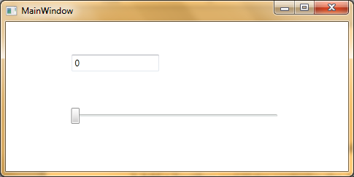

3.Set the minimum and maximum property of slider as 0 and 100 respectively.

<Slider Minimum="0" Maximum="100" ……………../>

4.Bind the TextBox with the Slider as below:

<TextBox Text="{Binding ElementName=slider1, Path=Value,UpdateSourceTrigger=PropertyChanged }"…........../>

5.Run and verify the Project.